

2010 FIRST Robotics Competition

Sensor Manual Rev A

The 2010 FIRST Robotics Competition (FRC) sensors are outlined in this document. It is being provided as a courtesy, and therefore does not supersede any information or rules provided in the 2010 FIRST Robotics Competition Manual.

Additional information on programming for these sensors may be found in the WPILib User’s Guide which is available through the 2010 FRC Control System Webpage http://www.usfirst.org/roboticsprograms/frc/content.aspx?id=10934
Analog Devices ADXL345 and ADW22307 Sensor Board

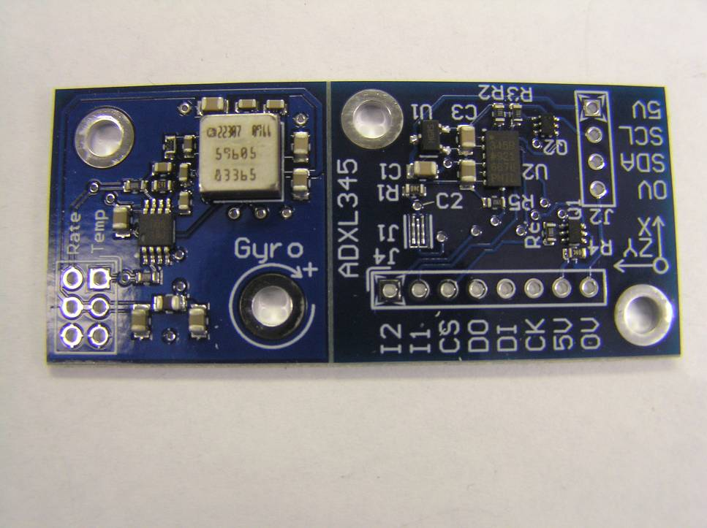

The sensor board in the 2010 FRC Kit of Parts hosts both an Analog Devices ADXL345 3-axis Digital Accelerometer and an Analog Devices ADW22307 1-axis Analog Gyroscope.

Teams may choose to use the board as is or to separate it along the scored line. Keeping the sensors connected may be helpful in cases where you want to use one to back up the other. For example, the gyroscope is very good at finding rate of angular change, but poor at finding absolute angle. The accelerometer can determine absolute angle when the robot is stable, but is easily confused when the robot moves.

To separate the two sensors, gently and slowly flex the board. Do not attempt to “snap” it, as you may damage the surface mounted components. Gradually increase the applied force until you hear the faint ripping noise of the fibers splitting. It will suddenly “give”, at which point you may bend it fully in half. Rub the newly separated edges together over a garbage can to remove any left over debris. Remember to follow proper ESD safety procedure any time you are handling the devices.

The dimensions of the printed circuit board are shown below. Units are mils (thousandths of an inch).

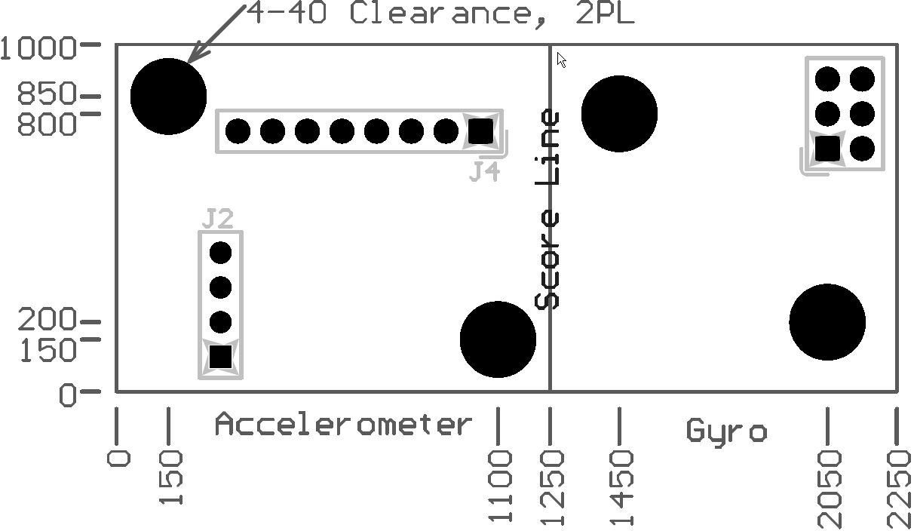
Digital Accelerometer

(Analog Devices PN ADXL345)

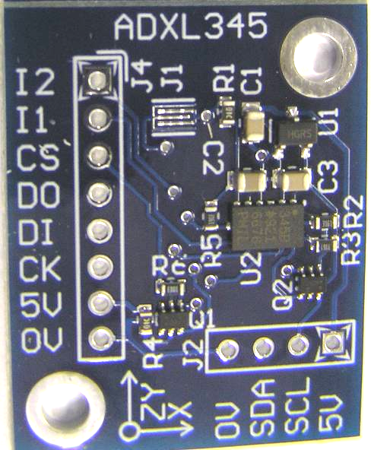

The 3-Axis Accelerometer measures both dynamic acceleration (vibration) and static acceleration (gravity). Accelerometers are sensitive to rough handling. Please remember to handle with care.

The module is designed to permit standoff mounting using 4-40 hardware. Note that plastic fasteners should always be used to isolate the PCB from chassis contact.

This sensor can communicate with the FRC system digitally with either of two protocols: I2C or SPI. The SPI port is found on J4 and was setup to be easily wired to the Digital I/O on the Digital Sidecar. Although the pins can be connected to any GPIOs in any order, it is easiest to use Digital I/O 1-4. Connect 0V and 5V to the (-) and PWR pins that are just beyond Digital I/O 1, and [CK, DI, DO, CS] in order.

The I2C port is found on J2 and was designed to be easily wired to the pins on the Digital Sidecar found directly behind the NXT connector. Connect 5V to 5V, SCL to SCL, SDA to SDA, and (-) to 0V. By default, the I2C address is 0x3A. The address can be set to 0xA6 by shorting J1 with a blob of solder.

Two optional interrupt pins, I1 and I2, are found at the end of the SPI connector but can be used with either I2C or SPI. These pins can be set to alert if the ADXL345 detects a tap (bump) or a fall, or they may be used for some of the advanced flow control functions. Connect one or both of them to any of the Digital I/O on the Digital Sidecar to use these functions.

Please see the code examples included with your software to get started with the ADXL345 once it is wired in. detailed operation of the Analog Devices ADXL345 accelerometer, refer to the Analog Devices website which can be found at http://www.analog.com/.

Note: The ADXL345 starts in a power saving mode. You must turn it on by writing 0x08 to POWER_CTL (0x2D) before it will do anything interesting.

Yaw Rate Gyro

(Analog Devices PN ADW22307)

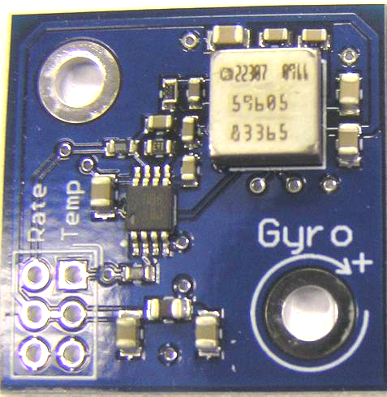

The angular rate sensor (gyroscope) senses angular changes about the top surface axis of the device and provides an output voltage proportional to the angular rate change. The output is useful for guidance, stability, and control of the robot platform. The lowest apparent drift on the gyro will occur when the module is mounted flat in or near the center axis of the robots rotation.

The module is designed to permit standoff mounting using 4-40 hardware. Note that plastic fasteners should always be used to isolate the PCB from chassis contact.

The ADW22307 can measure up to 250°/s of rotation. Nominal output is 2.5V at standstill, plus 7mV/°/s. The carrier board adds a double pole low-pass filter set to 400Hz: Teams are encouraged to experiment with digital filters in order to select a bandwidth appropriate for their specific usage.

The ADW22307 has an integrated temperature sensor to assist in temperature compensation. Nominal output is 2.5V at 25°C plus 9mV/°C.

Pin-out is as follows, in same orientation as photo above:

Rate | Temperature
+5V | +5V
Ground | Ground

Please refer to the datasheet, which may be found on the 2010 FIRST Robotics Competition Manual and Related Documents Page at http://www.usfirst.org/roboticsprograms/frc/content.aspx?id=452, for tolerances and other specifications.

austriamicrosystems Magnetic Encoder

(austriamicrosystems PN AS5030)

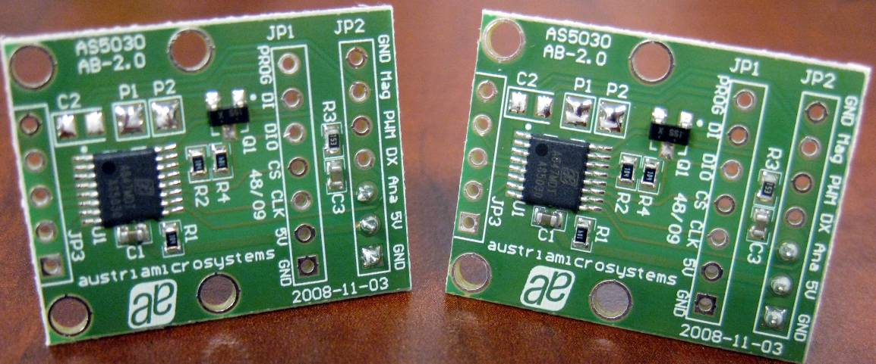
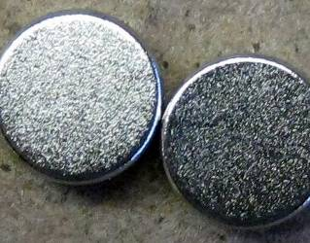

The AS5030 is a contactless magnetic rotary encoder that can be used to measure absolute angle (8 bits over 360 degrees), angular rate (up to 30,000 RPM), and magnetic field strength (6 bits) by looking at the field created by a 2-pole magnet rotating over the center of the chip. Two boards and two magnets are included in the 2010 Kit of Parts. It can be used in applications that typically used potentiometers or quadrature encoders. It has less resolution than the provided encoders from US Digital, but is rated for a higher maximum speed and does not require mechanical coupling between the sensor and the shaft being measured.

The module is designed to permit standoff mounting using appropriate hardware. Note that plastic fasteners should always be used to isolate the PCB from chassis contact.

There are 4 supported communication methods for this device, listed below in order of increasing complexity. Each has benefits and drawbacks and must be selected based on the application.
- Filtered PWM: Connect the Ana pin (JP2.3) to an input pin on the Analog Breakout. The voltage is proportional to the angle. NOTE: There is a 4.8 Hz filter on this output, so it is only useable for very low bandwidth (slowly moving) angular position measurements and is not appropriate in angular rate applications. This output can be sampled at 10Hz.
- PWM: Connect the PWM pin (JP2.5) to a Digital I/O pin on the Digital Sidecar. The pulse length is proportional to the angle. This option is best suited for angular position measurement, but has a much higher bandwidth that Option 1 and therefore can be used for some moderate angular rate measurements. This option has lower resolution (~6-bit) due to the sampling rate of the digital input. This output can be sampled at 1.7 kHz.
- Analog Sine-Cosine: Clear P1 of solder. JP3 now presents the raw analog sine and cosine voltage. Connect the SIN and COS signals to the Analog Breakout. You must also power the sensor with 5V from the analog breakout. This option is the only one that can support high-speed angular rate applications (up to 30,000 RPM). It is also the best option for tracking position across multiple rotations.
- 4 Wire SPI Mode: Enabled by default on JP1. Same as Option 5, but the DI pin (JP1.6) is used for commands and the DIO pin (JP1.5) is used for data output. This allows for operation with the Digital Sidecar because all lines are uni-directional. This mode is best suited for angular position measurement with multiple sensors sharing a bus. The data also indicates magnet proximity. Because this is a digital data interface it can deliver the position with no encoding error, unlike Options 1 and 2. This output can be sampled at 3.5 kHz. NOTE: Commands sent using the DI pin are inverted.
- 3 Wire SPI Mode: Enabled by default on JP1. See Datasheet for details on operation. This option is not available when using the Digital Sidecar because it does not support a bi-directional DIO line.
- 2 Wire SPI Mode: Enabled on JP1 by clearing P2 of solder. See Datasheet for details of operation. This option is not available when using the Digital Sidecar because it does not support a bi-directional DIO line.

The MAG pin (JP2.6) can be used to determine if the magnet is too far from the sensor. If out of range, the MAG pin will be high. If the magnet is detected, MAG will be low.

Magnet placement requirements, along with other details on this unit, are included in the user manual, which may be found on the 2010 FIRST Robotics Competition Manual and Related Documents Page at http://www.usfirst.org/roboticsprograms/frc/content.aspx?id=452. Teams are encouraged to review this information.

US Digital Encoder

(US Digital PN E4P-360-250-S4149)

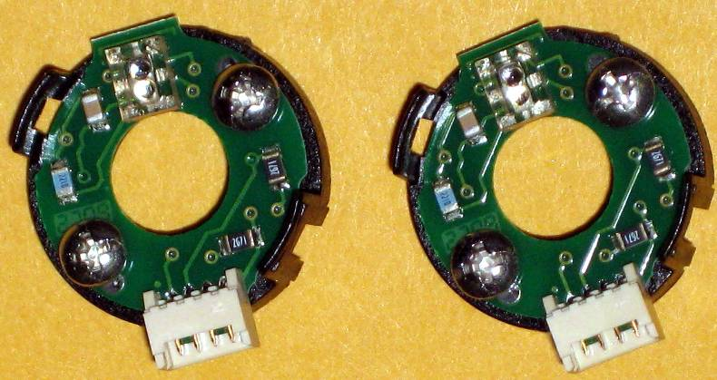

The US Digital E4Ps are incremental encoders outputting a 2-channel quadrature signal. They are capable of measuring shaft position, speed and direction, and fit on a 0.25" shaft. The encoders provided are 360 Codes per Revolution (CPR). With 4X quadrature decoding, you get 1,440 positions per revolution, which gives you a unique position every 0.25 degrees. The maximum RPM for these encoders is 10,000 RPM.

Much more detail on these encoders is available on US Digital’s FIRST webpage, www.usdigital.com/first

